**events, event handlers**

The change in the state of an object is known as an Event. In html, there are various events which represents that some activity is performed by the user or by the browser. When JavaScript code is included in HTML, js react over these events and allow the execution. This process of reacting over the events is called Event Handling. Thus, js handles the HTML events via Event Handlers.

For example, when a user clicks over the browser, add js code, which will execute the task to be performed on the event.

Some of the HTML events and their event handlers are:

**Mouse events:**

|  |  |  |
| --- | --- | --- |
| **Event Performed** | **Event Handler** | **Description** |
| click | onclick | When mouse click on an element |
| mouseover | onmouseover | When the cursor of the mouse comes over the element |
| mouseout | onmouseout | When the cursor of the mouse leaves an element |
| mousedown | onmousedown | When the mouse button is pressed over the element |
| mouseup | onmouseup | When the mouse button is released over the element |
| mousemove | onmousemove | When the mouse movement takes place. |

**Keyboard events:**

|  |  |  |
| --- | --- | --- |
| **Event Performed** | **Event Handler** | **Description** |
| Keydown & Keyup | onkeydown & onkeyup | When the user press and then release the key |

**Form events:**

|  |  |  |
| --- | --- | --- |
| **Event Performed** | **Event Handler** | **Description** |
| focus | onfocus | When the user focuses on an element |
| submit | onsubmit | When the user submits the form |
| blur | onblur | When the focus is away from a form element |
| change | onchange | When the user modifies or changes the value of a form element |

**Window/Document events**

|  |  |  |
| --- | --- | --- |
| **Event Performed** | **Event Handler** | **Description** |
| load | onload | When the browser finishes the loading of the page |
| unload | onunload | When the visitor leaves the current webpage, the browser unloads it |
| resize | onresize | When the visitor resizes the window of the browser |

Click Event

**<html>**

**<head>** Javascript Events **</head>**

**<body>**

**<script** language="Javascript" type="text/Javascript"**>**

    <!--

    function clickevent()

    {

        document.write("This is JavaTpoint");

    }

    //--**>**

**</script>**

**<form>**

**<input** type="button" onclick="clickevent()" value="Who's this?"**/>**

**</form>**

**</body>**

**</html>**

[**Test it Now**](https://www.javatpoint.com/oprweb/test.jsp?filename=JavaScriptClickEvent)

**MouseOver Event**

**<html>**

**<head>**

**<h1>** Javascript Events **</h1>**

**</head>**

**<body>**

**<script** language="Javascript" type="text/Javascript"**>**

    <!--

    function mouseoverevent()

    {

        alert("This is JavaTpoint");

    }

    //--**>**

**</script>**

**<p** onmouseover="mouseoverevent()"**>** Keep cursor over me**</p>**

**</body>**

**</html>**

[**Test it Now**](https://www.javatpoint.com/oprweb/test.jsp?filename=JavaScriptMouseOverEvent)

**Focus Event**

**<html>**

**<head>** Javascript Events**</head>**

**<body>**

**<h2>** Enter something here**</h2>**

**<input** type="text" id="input1" onfocus="focusevent()"**/>**

**<script>**

<!--

    function focusevent()

    {

        document.getElementById("input1").style.background=" aqua";

    }

//--**>**

**</script>**

**</body>**

**</html>**

[**Test it Now**](https://www.javatpoint.com/oprweb/test.jsp?filename=JavaScriptFocusEvent)

**Keydown Event**

**<html>**

**<head>** Javascript Events**</head>**

**<body>**

**<h2>** Enter something here**</h2>**

**<input** type="text" id="input1" onkeydown="keydownevent()"**/>**

**<script>**

<!--

    function keydownevent()

    {

        document.getElementById("input1");

        alert("Pressed a key");

    }

//--**>**

**</script>**

**</body>**

**</html>**

[**Test it Now**](https://www.javatpoint.com/oprweb/test.jsp?filename=JavaScriptKeydownEvent)

**Load event**

**<html>**

**<head>**Javascript Events**</head>**

**</br>**

**<body** onload="window.alert('Page successfully loaded');"**>**

**<script>**

<!--

document.write("The page is loaded successfully");

//--**>**

**</script>**

**</body>**

**</html>**

[**Test it Now**](https://www.javatpoint.com/oprweb/test.jsp?filename=JavaScriptLoadEvent)

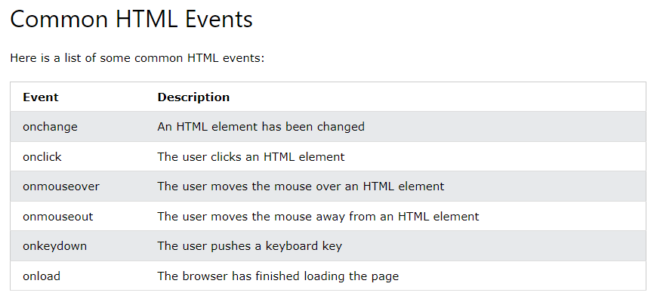

**Examples**

Event with arrow function

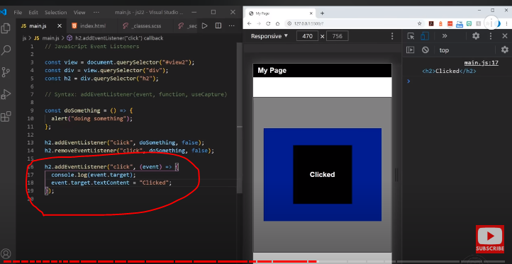

Event with normal function

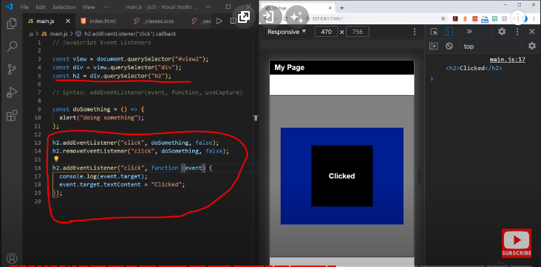

**2 example**

<button id="btn">Click Me!</button>

To define the code that will be executed when the button is clicked, you need to register an event handler using the addEventListener() method:

let btn = document.querySelector('#btn');

function display() {

alert('It was clicked!');

}

btn.addEventListener('click',display);

Assuming that you have the following HTML document:

<!DOCTYPE html>

<html>

<head>

<title>JS Event Demo</title>

</head>

<body>

<div id="container">

<button id='btn'>Click Me!</button>

</div>

</body>

A shorter way to register an event handler is to place all code in an anonymous function, like this:

let btn = document.querySelector('#btn');

btn.addEventListener('click',function() {

alert('It was clicked!');

});

Code language: JavaScript (javascript)

**onmouserover example**

Classlist add()method

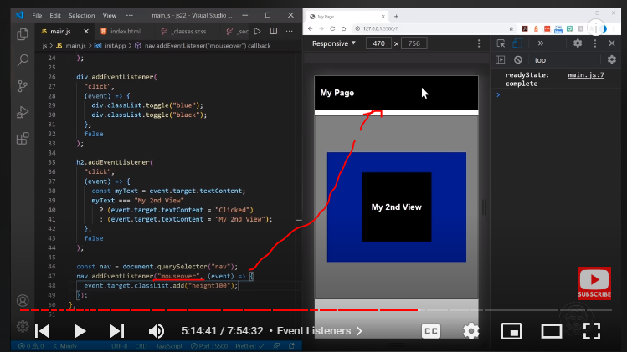

Class list toggle()

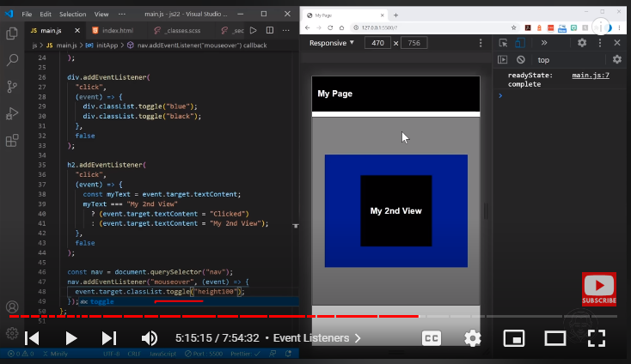

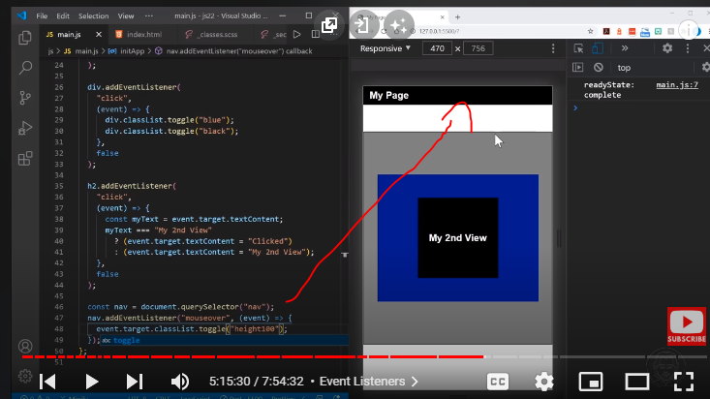

**Using onmouseover and onmouseout example**

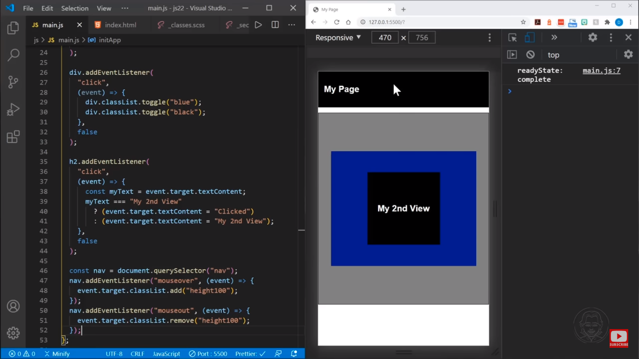

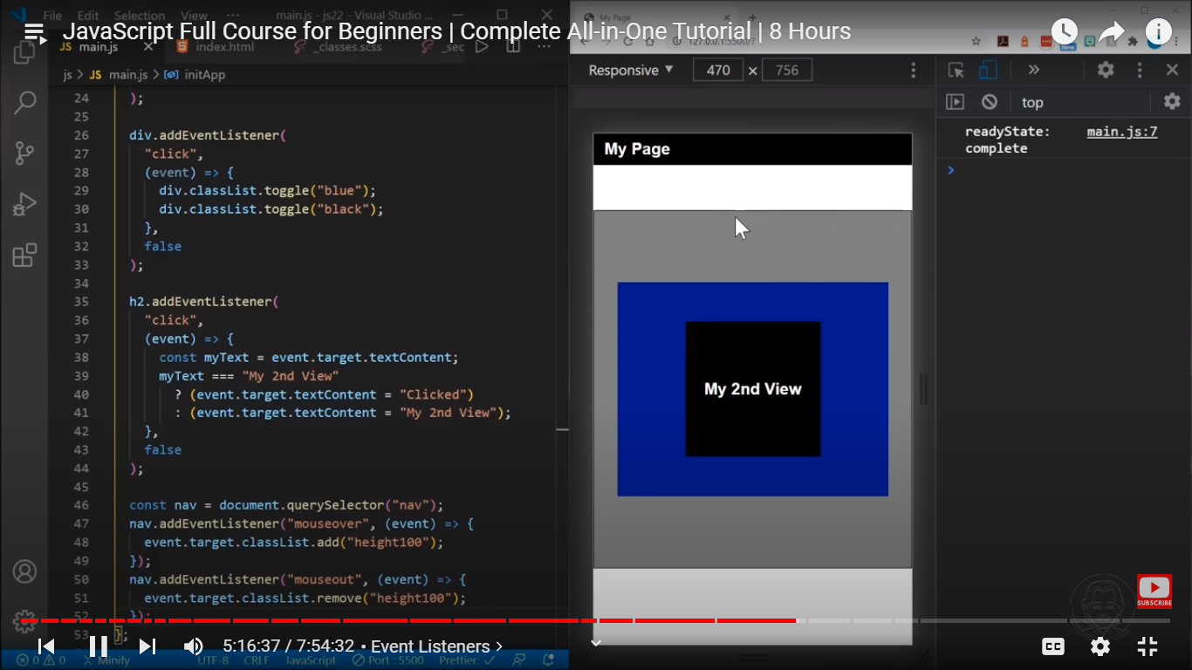

**Onsubmit on submitting prevent default**

